Table of Contents
1 Introduction 1
2 Setup and Configuration 1
2.1 Installation 1
2.2 JBoss Developer Studio Configuration 2
2.3 Start the JBoss Enterprise BRMS Platform 4
2.4 Importing Project Repository into BRM 4
3 Running the Demo 5
3.1 JBDS IDE unit test 5
3.2 BRMS BRM demo 6
Web Designer 6
Build package for deployment 6
3.3 Cool Store Demo deployment 6
3.4 Cool Store Demo deployment 7

Introduction
This is a BRMS demo application setup guide for the Cool Store Demo. The setup will create a fully installed and configured BRMS environment so that you can demo the project in all the available jBPM components. It will provide you with a JBoss Developer Studio project with unit tests to demo the project in the IDE. It will provide a repository that you can import into BRMS BRM and demo the web tooling, web business central admin console and asset manager BRM tooling.

Setup and Configuration

Installation
You first need to extract the demo distribution zip (brms-coolstore-demo-[version].zip) to a location of your choosing. Once extracted, you will have the following folder structure:
- \brms-coolstore-demo
  - \installs – Initially empty, but will contain the BRMS platform downloads.
  - \projects – The project that comprise the demo.
  - \support – Additional supporting files used by the demo.
  - \target – Will be created by running init.sh. Contains the fully configured BRMS runtime server.
  - init.sh – Script to install and configure the run time server environment.
  - Quick Start Guide.odt – This document
Next, download JBoss Enterprise BRMS Platform from the Red Hat Customer Portal (https://access.redhat.com/jbossnetwork).

Download BRMS Platform:
- Under JBoss Enterprise Platforms, select the BRMS Platform product.
- Select version 5.3.1 in the Version field.
- Download JBoss BRMS 5.3.1 Deployable for EAP 6
(Please note that this is the deployable distribution, not the standalone one.)

Now copy brms-p-5.3.1.GA-deployable-ee6.zip, to the brms-coolstore-demo's installs folder. Ensure that this file is executable by running:

$ chmod +x <path-to-project>/installs/brms-p-5.3.1.GA-deployable-ee6.zip

Download EAP 6 Platform:
- Under JBoss Enterprise Platforms, select the Application Platform product.
- Select version 6.0.1 in the Version field.
- Download Aplication Platform 6.0.1

Now copy jboss-eap-6.0.1.zip, to the brms-coolstore-demo's installs folder. Ensure that this file is executable by running:

$ chmod +x <path-to-project>/installs/jboss-eap-6.0.1.GA.zip

Download EAP 6 Maven Repository:
- Under JBoss Enterprise Platforms, select the Application Platform product.
- Select version 6.0.1 in the Version field.
- Download Application Platform 6.0.1 Maven Repository

Now copy jboss-eap-6.0.1-maven-repository.zip, to the brms-coolstore-demo's installs folder. Ensure that this file is executable by running:

$ chmod +x <path-to-project>/installs/jboss-eap-6.0.1-maven-repository.zip

Lastly, from the brms-coolstore-demo folder, run the init.sh script:

$ ./init.sh

When the script completes you will have a new folder named jboss-eap-6.0, in the brms-coolstore-demo's target folder. The folder is a ready to run EAP 6 server with BRMS 5.3.1 with the following modifications made:
- The admin, krisv, mary, john, erics accounts enabled (passwords are same as users name) in the brms-roles.properties and brms-users.properties file in brms-coolstore-demo/target/jboss-eap-6.0/jboss-as/standalone/configuration
- Adjusted server security domain to include brms, copied new standalone.xml to brms-coolstore-demo/target/jboss-eap-6.0/jboss-as/standalone/configuration
- Added patched process designer, designer.war.

JBoss Developer Studio Configuration
In this section, you will configure JBoss Developer Studio. Specifically you will add the BRMS 5.3.1 platform server runtime environment and then import the project that makes up the BRMS Rewards Demo.
Important: It is assumed that you already have JBoss Developer Studio installed. This demo has been tested with JBoss Developer Studio 6 (latest).
Launch JBoss Developer Studio
- Either select or switch to a new workspace by pointing to the brms-coolstore-demo/projects folder.
- If the Welcome to JBoss Developer Studio screen appears, dismiss it by click the Workbench arrow in the upper right.

Setup EAP 6 Server
- Select the Servers view
If it is currently not open, select Show View --> Other... from the Window menu and search for the Servers view.
- Click new server wizard...
- Select JBoss Enterprise Application Platform 6.x. Click Next.
- Set Home Directory to brms-coolstore-demo/target/jboss-eap-6.0.
- Click Finish.

Install SOA tools for BRMS
- Select Help → Install New Software... and add SOA Tools update site https://devstudio.jboss.com/updates/5.0/central/soa-tooling/
- Select Business Rules Tooling & SOA and Data Services Tooling (all sub-menu items will be selected) and proceed thru installation and restart JBoss Developer Studio to complete the installation. You will be told to restart JBoss Developer Studio for the changes to take effect, do this now.

Detect and add a BRMS 5.3.1 runtime environment
- Select Preferences from the Window menu.
- In the left hand side, expand JBoss Tools and then select JBoss Tool Runtime Detection
- Select the Add button and navigate to the brms-coolstore-demo/target folder (not brms-coolstore-demo/projects/brms-coolstore-demo/target), then select OK.
- The jboss-eap-6.0 runtime created earlier should have been found and selected. If so, select OK.
- Select OK again to close the Preferences dialog window.

Detect and add jBPM BRMS 5.3.1 runtime environment
- Select Preferences from the Window menu.
- In the left hand side, expand jBPM and then select Installed jBPM Runtimes
- If not automatically listed in the view: Select the Add button, then the Create a new jBPM Runtime... button and navigate to the brms-coolstore-demo/target/jboss-eap-6.0 folder, then name the runtime jBPM BRMS 5.3.1 runtime and select OK.
- The jBPM BRMS 5.3.1 runtime should be selected. If so, select OK to close the Preferences dialog window. If not, click box to add check mark next to runtime and then select OK.
- If asked to restart JBoss Developer Studio for the changes to take effect, restart.

Detect and add Drools 5.3.1 runtime environment
- Select Preferences from the Window menu.
- In the left hand side, expand Drools and then select Installed Drools Runtimes
- If not automatically listed in the view: Select the Add button, then the Create a new Drools 5 Runtime... button and navigate to the brms-coolstore-demo/target/jboss-eap-6.0 folder, then name the runtime Drools 5.3.1.Final runtime and select OK.
- Select the Drools 5.3.1.Final runtime.
- In Drools in the left hand side menu select Drools Flow nodes, make sure all boxes are checked and select OK to close the Preferences dialog window.
- You will be told to restart JBoss Developer Studio for the changes to take effect, do this now.

Import Projects
- Select Import... from the File menu.
- Expand the General folder, and then select Existing Projects into Workspace
- Select the Browse button to Select root directory, you should be in the brms-coolstore-demo folder (if not, then navigate there) and then select OK.
- Make sure the project brms-coolstore-demo is selected and then select Finish.
- The project is now imported.

Start the JBoss Enterprise BRMS Platform
In this section, you will start the server from within JBoss Developer Studio.
- Select the Servers view
- You should see the JBoss EAP 6.0 Runtime Server you created earlier.
- Right click on JBoss EAP 6.0 Runtime Server and select Start from the pop-up menu. In a few moments your JBoss Enterprise BRMS Platform will be running.

Importing Project Repository into BRM
In this section, you will import all of the JBoss Enterprise BRMS artifacts into the Business Rules Manager.
- Open up your Web browser of choice and navigate to http://localhost:8080/jboss-brms/
- Use the default credentials of admin/admin
- Upon logging in, you will see the following prompt:
This looks like a brand new repository.
Would you like to install a sample repository?
Important: Please be sure to select No thanks.
- Select the Administration section on the left hand side
- From the Administration list select Import Export. This will open the Import Export window.
- Now select Browse... and navigate to brms-coolstore-demo/support folder and select the repository_export.zip file.
- Lastly, select the Import button. Select OK to confirm that you want to import the artifacts.
- Build the package by selecting from the left navigation Knowledge Bases → Packages → com → redhat →coolstore → Edit tab → Build Package button.

Running the Demo

Goals of this demo
This demo comes to you from the field, a JBoss Solution Architect Jason Milliron wanted to look at the following:
- create a JBoss BRMS solution for an online shopping cart.
- create easy to understand web application where able to apply changes to business logic in JBoss BRMS while viewers see web application updated without restarting application / server.
- create web application using JavaEE, third party development framework (Vaadin) and CDI technology.

Demo setup from CLI
The following steps will run through the demo components without using JBDS:
- setup project as described in Readme by using init.sh.
- build project in projects/brms-coolstore-demo
  - mvn clean install
- copy from projects to EAP server
  - cp projects/brms-coolstore-demo/target/brms-coolstore-demo.war target/jboss-eap-6.0/standalone/deployments/
- start JBoss EAP
- import project (support/repository-export.zip) into BRM (http://localhost:8080/jboss-brms)
- build project in BRM
- open web application (http://localhost:8080/brms-coolstore-demo), note Checkout button is disabled by design, the demo is about rules changing the discounts of products as you select and put them into your cart.
- see video of demo for changing business logic in rules and showing application picking these changes up.
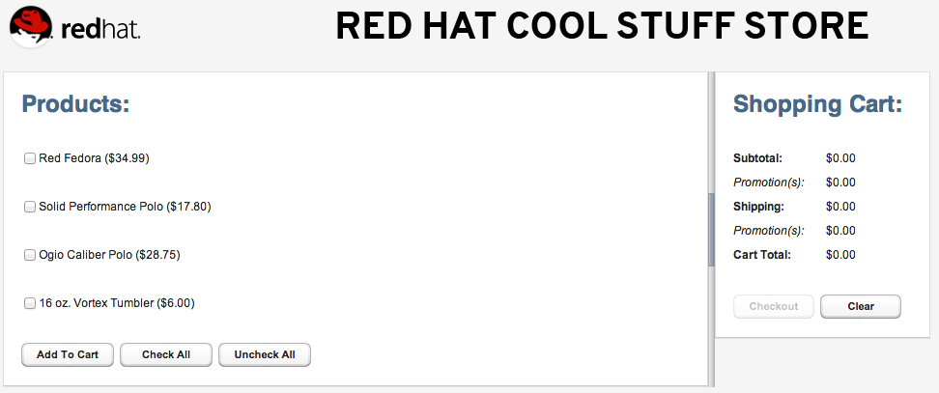Illustration 1: Red Hat JBoss BRMS CoolStore

JBDS IDE unit test
Unit Testing
The following will run the demo process with two unit tests:
- Right-click the brms-coolstore-demo project and select Properties.
- Select the Maven option in the tree on the left.
- Set Active Maven Profile to arq-jbossas-remote, ensure “Resolve dependencies from Workspace projects” is checked. Click Yes when asked to update the project configuration. Click OK button to close Properties dialog.
- Select the file brms-coolstore-demo/Java Resources/src/test/java/com.redhat.coolstore.service.ShoppingCartServiceTest.java, right click, Run As..., JUnit Test.
Illustration 2: ShoppingCartServiceTest run
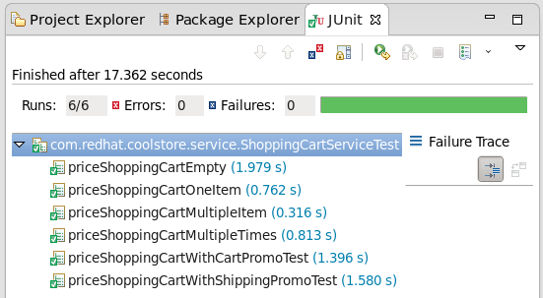

BRMS BRM demo
The package was already imported so now we can look closer at web designers viewing, rules asset viewing, package building and deploying, web business central admin console viewing.

Web Designer
The BRM is available on http://localhost:8080/jboss-brms once the BRMS server has been fully started.
- Login with a user (admin, krisv, mary, john, erics available). To start fresh you can at any time import the original repository as follows: Administration → Import Export → Choose File ->brms-coolstore-demo/support/repository-export.zip → Import (Ok to pop-ups)

Build package for deployment
To build your package for deployment:
- Build package: Knowledge Bases → Packages → com → redhat →coolstore → Edit tab → Build Package button.

Cool Store Demo deployment
In this section, you will deploy the application to the server from within JBoss Developer Studio.
- Select the Servers view
If it is currently not open, select Show View --> Other... from the Window menu and search for the Servers view.
- If the server is not running, right click on JBoss EAP 6.0 Runtime Server and select Start from the pop-up menu. In a few moments your JBoss Enterprise BRMS Platform will be running.
- Right-click on JBoss EAP 6.0 Runtime Server and select Add and Remove... from the pop-up menu.
- Select brms-coolstore-demo from the list of Available resources and click the Add > button to move it to the Configured resources section.
- Click Finish.

Cool Store Demo deployment
- Open up your Web browser of choice and navigate to http://localhost:8080/brms-coolstore-demo, should see Illustration 1.

